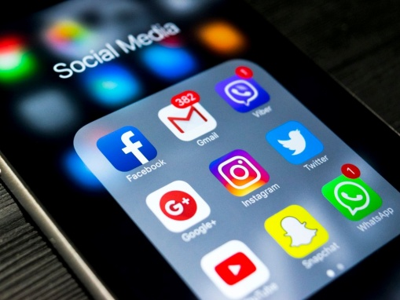**Six ways social media negatively affects your mental health**

Haut du formulaire

Bas du formulaire

The rise of social media has meant that we as a global population are more connected than we have ever been in the history of time. However, our reliance on social media can have a detrimental effect on our mental health, with the average Brit checking their phone as much [28 times a day](https://www.independent.co.uk/life-style/gadgets-and-tech/average-briton-check-phone-10000-times-year-uk-study-iphone-samsung-smartphone-a8086631.html).

While social media platforms can have their benefits, using them too frequently can make you feel increasingly unhappy and isolated in the long run.

The constant barrage of perfectly filtered photos that appear on Instagram are bound to knock many people’s self-esteem, while obsessively checking your Twitter feed just before bed could be contributing towards poor quality of sleep.

**Self-esteem**

We all have our fair share of insecurities, some that we speak about openly and others that we prefer to keep to ourselves. However, comparing yourself to others on social media by stalking their aesthetically perfect Instagram photos or staying up to date with their relationship status on Facebook could do little to assuage your feelings of self-doubt.

A study conducted by the University of Copenhagen found that many people suffer from “[Facebook envy](https://www.independent.co.uk/life-style/gadgets-and-tech/facebook-social-media-make-unhappy-jealous-people-particularly-sad-copenhagen-university-study-a7490816.html)”, with those who abstained from using the popular site reporting that they felt more satisfied with their lives.

“When we derive a sense of worth based on how we are doing relative to others, we place our happiness in a variable that is completely beyond our control,” Dr Tim Bono, author of *When Likes Aren’t Enough* explained in [*Healthista*](https://www.healthista.com/reasons-social-media-making-you-unhappy/).

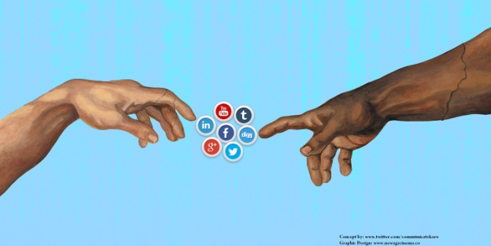

**Human connection**

As human beings, it’s so important for us to be able to communicate and forge personal connections with one another. However, it can be hard to do so when we’re glued to rectangular screens, becoming more acquainted with our friends’ digital facades than their real-life personas.

Stina Sanders, a former model who has 107,000 followers on Instagram, explained how social media sometimes makes her feel like she’s being left out.

“I know from my experience I can get FOMO when I see my friend’s photos of a party I didn’t go to, and this, in turn, can make me feel quite lonely and anxious,” she told [*The Independent*](https://www.independent.co.uk/life-style/gadgets-and-tech/quitting-social-media-facebook-instagram-snapchat-key-to-happiness-mental-health-relax-a7534151.html).

A study published in the [*American Journal of Epidemiology*](https://academic.oup.com/aje/article/185/3/203/2915143) that assessed 5,208 subjects found that overall, regular use of Facebook had a negative impact on an individual’s wellbeing.

**Memory**

Social media can be great for looking back fondly on memories and recounting how past events occurred.  However, it can also distort the way in which you remember certain tidbits from your life. Many of us are guilty of spending far too much time trying to take the perfect photo of a visual marvel, all the while not actually absorbing the firsthand experience of witnessing it with your own two eyes.

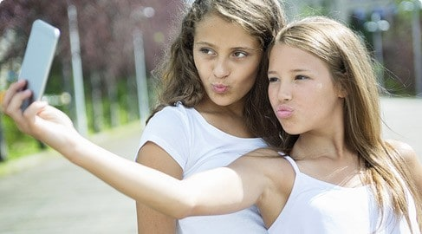“If we direct all of our attention toward capturing the best shots for our social media followers to admire, less will be available to enjoy other aspects of the experience in real time,” said Dr Bono.

“Spending too much time on our phones will detract from those other aspects of the experience, undermining the happiness we could be gleaning from them.”

**Sleep**

Having enough sleep is of paramount importance. However, many of us use our phones too soon before choosing the hit the hay, making it harder to doze off.

“Getting worked up with anxiety or envy from what we see on social media keeps the brain on high alert, preventing us from falling asleep,” explained Dr Bono.

“Plus, the light from our mobile device just inches from our face can suppress the release of melatonin, a hormone that helps us feel tired.”

**Attention span**

It’s not just your subconscious brain that you need to worry about, but also the extent to which your brain is able to fully concentrate when you’re awake. While it’s incredible to consider the amount of information readily available at our fingertips thanks to social media, it also means that people have become far more easily distracted.

“Social media has provided a means of constantly giving into the temptation of instant, easy-access entertainment,” said Dr Bono.

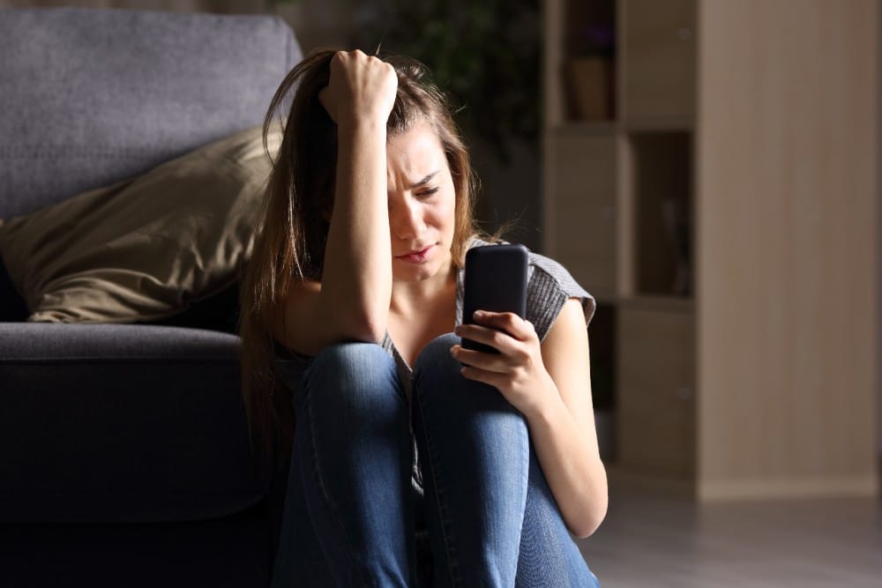**Mental health**

Not only has social media been proven to cause unhappiness, but it can also lead to the development of mental health issues such as anxiety or depression when used too much or without caution.

In March, it was reported that more than a third of Generation Z from a [survey](https://www.prweek.com/article/1459149/gen-z-quitting-social-media-droves-makes-unhappy-study-finds) of 1,000 individuals stated that they were quitting social media for good as 41 per cent stated that social media platforms make them feel anxious, sad or depressed.

Ben Jacobs, a DJ who has more than 5,000 followers on Twitter, decided to go on a hiatus from the platform in January 2016 and has found the break really beneficial.

“Twitter did indeed make me feel anxious from time to time as it slowly dawned on me I was concerning myself with the feelings of the thousands of strangers I followed, while they didn’t necessarily know who I was,” he said.

“Since my Twitter hiatus, I have had a clearer head with plenty of time to devote to other things such as waking up in a cold sweat at 3am and reading a book instead.”

While you don’t necessarily have to quit social media for good, if you feel like it’s beginning to bog you down, why not consider allocating social media-free time slots during your daily routine? The slight change could do you a whole lot of good.

Wednesday 7 November 2018 13:00 www.independent.co.uk/

**Match the words on the right with their meaning.**

_1___ reliance __8-1_to create, to form

_2___ detrimental 2-____ to reach or obtain by reasoning

3____ barrage 3- to soothe, calm

4____ to assuage 3- an overwhelming quantity

5____ to abstain _4___ value

6____ to derive 5- the.state of needing someone or something for aid, support, or the like

7____ worth 6-____ to hold oneself back voluntarily

__8-1__ to forge ____ damaging; harmful.

**Match the words on the right with their synonym.**

_1-5___ to distort _7-1___ **pause, interruption**

2-3____ tidbits 2____ important

3____ to undermine 3-2____ **tiny portion**

4____ to glean 4____ **troubled**

5____ paramount 5-1____ **deform; falsify**

6____ distracted 6____ **pick out, collect**

_7-1___ hiatus 7____ **sabotage**

**Fill in the gaps with the comparative and superlative.**

The rise of social media has meant that we are _______________connected than we have ever been in the history of time.

Many of us are guilty of spending far too much time trying to take the ___________________ perfect photo.

Using a mobile phone before doing to bed makes it ______more difficult______________(difficult) to sleep.

Social media platforms make some people feel ________________(anxious),______________(sad) and __________________ (depressed) than others.

Answer the following questions. Justify your response with quotes from the text.

1 Dependence on social media can have a negative effect on our mental health. True False

TRUE

________________________________________________________

2. The constant barrage of perfect photos that appear on Instagram can have a positive effect on peoples' self esteem. True False

__________FALSE______________________________________________

________________________________________________________

3. What did the study conducted by the University of Copenhagen find

_the University of Copenhagen found that many people suffer from “[Facebook envy](https://www.independent.co.uk/life-style/gadgets-and-tech/facebook-social-media-make-unhappy-jealous-people-particularly-sad-copenhagen-university-study-a7490816.html)”, with those who abstained from using the popular site reporting that they felt more satisfied with their lives_______________________________________________________

________________________________________________________

4. What does FOMO mean?

___[**fear**](https://dictionary.cambridge.org/dictionary/english/fear)**of**[**missing**](https://dictionary.cambridge.org/dictionary/english/missing)**out, a**[**worried**](https://dictionary.cambridge.org/dictionary/english/worried)[**feeling**](https://dictionary.cambridge.org/dictionary/english/feeling)**that you may**[**miss**](https://dictionary.cambridge.org/dictionary/english/miss)[**exciting**](https://dictionary.cambridge.org/dictionary/english/excite)[**events**](https://dictionary.cambridge.org/dictionary/english/event)**that other**[**people**](https://dictionary.cambridge.org/dictionary/english/people)**are going to,**[**especially**](https://dictionary.cambridge.org/dictionary/english/especially)[**caused**](https://dictionary.cambridge.org/dictionary/english/cause)**by things you**[**see**](https://dictionary.cambridge.org/dictionary/english/see)**on**[**social**](https://dictionary.cambridge.org/dictionary/english/social)[**media**](https://dictionary.cambridge.org/dictionary/english/media)_____________________________________________________

________________________________________________________

5. How did FOMO effect Stina Sanders ?

__ I know from my experience I can get FOMO when I see my friend’s photos of a party I didn’t go to, and this, in turn, can make me feel quite lonely and anxious,” ______________________________________________________

________________________________________________________

6.How does Social media distort the way in which you remember certain events from your life?

___ Many of us are guilty of spending far too much time trying to take the perfect photo of a visual marvel, all the while not actually absorbing the firsthand experience of witnessing it with your own two eyes._____________________________________________________

________________________________________________________

7. How, according to Dr Bono, does social media effect your attention span.?

incredible to consider the amount of information readily available at our fingertips thanks to social media, it also means that people have become far more easily distracted. Social media has provided a means of constantly giving into the temptation of instant, easy-access entertainment

____________________________________________________

________________________________________________________

8. Social media can lead to the development of mental health issues. Name 3 and give statistics.

__ **Sleep:** Having enough sleep is of paramount importance. However, many of us use our phones too soon before choosing the hit the hay, making it harder to doze off.

“Getting worked up with anxiety or envy from what we see on social media keeps the brain on high alert, preventing us from falling asleep

___ **Mental health** : the development of mental health issues such as anxiety or depression when used too much or without caution.

**Attention span:** people have become far more easily distracted.

___________________________________________________

________________________________________________________

9. What does Ben Jacobs say about social media?

___ Twitter did indeed make me feel anxious from time to time as it slowly dawned on me I was concerning myself with the feelings of the thousands of strangers I followed, while they didn’t necessarily know who I was,” he said.

_____________________________________________________

________________________________________________________

Does social media play an important role in your life.? Write 180 words.

**____________________________________________________________________________________**

**__Social media is important to me because I can see world news, talk to my family, school, end work. In other cases, I don’t see any importance in having social media__________________________________________________________________________________**

**____________________________________________________________________________________**

**____________________________________________________________________________________**

**____________________________________________________________________________________**

**____________________________________________________________________________________**

**____________________________________________________________________________________**

**____________________________________________________________________________________**

**____________________________________________________________________________________**

Describe, discuss and Analyze the following documents.

























